End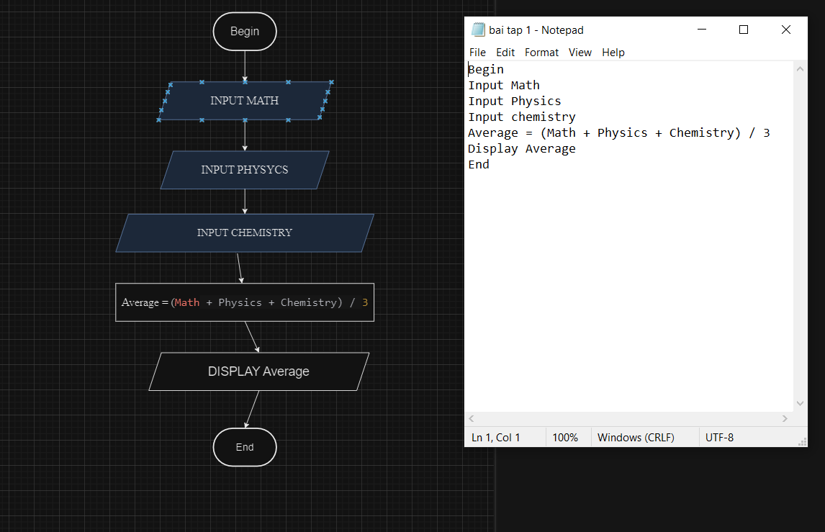

DISPLAY average

Average = (**Math** + physics + chemistry)/3

INPUS CHEMISTRY

INPUT PHYSICS

INPUT MATH

Bengin

Begin

Input math

Input physics

Input chemistry

Average = (Math + Physics + chemistry )/3

Display Average

End